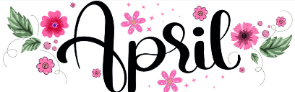
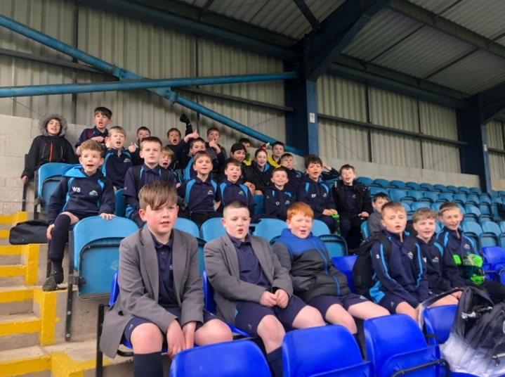

Reading Rocks Newsletter
Our second Reading Rocks Newsletter.
We are passionate about promoting books and a love of reading at Churnet View Middle School. The benefits of reading to children are huge – both academically and personally.
To view our first Reading Rocks Newsletter, please click on the following link:
https://cvm.ttlt.org.uk/newsletters/reading-newsletter/
Important Reminder:
Due to Health and Safety reasons can parents please refrain from driving onto the school grounds, unless collecting for an appointment or illness. This is especially important in the morning and at the end of school, due to busses and limited space.
If your child is late in the morning please press the button on the pedestrian gate for your child to walk down to reception, you are welcome to accompany them.
Thank you for your understanding.
Year 5 and 6 Football
A big well done to both our year 5 and 6 football teams who took part in a 6-a-side football tournament on Tuesday at Leek Town`s F Ball Stadium. Our teams produced some excellent displays of skills, teamwork and resilience. We witnessed some outstanding goals, perfect passes and great cohesion. Both our year 5 teams finished in second place and despite our year 6 teams not winning a game, they have made great progress from their previous tournament. Well done all!

Behaviour Commitments
As shared previously, pupils and staff have developed the school behaviour commitments. They are:
Be safe, Be kind, Be ready
Be respectful, Be the best that you can be.
We ask that you support us with reinforcing our behaviour commitments which seek to prepare pupils for life after school. The focus is on positive relationships and making the best effort that they can with all areas of school life. A copy of the posters shared with pupils around school can be found on our school’s website.
https://cvm.ttlt.org.uk/wp-content/uploads/sites/11/2023/05/Behaviour-policy-22-23.pdf
Important Dates
Monday 15th April: Year 8 Parent/carer evening.
May Day: Monday 6th May
Summer half-term: Monday 27th May – Friday 31st May
Summer holiday:
Monday 22nd July – Friday 30th August
Churnet View Newsletter
12th April 2024



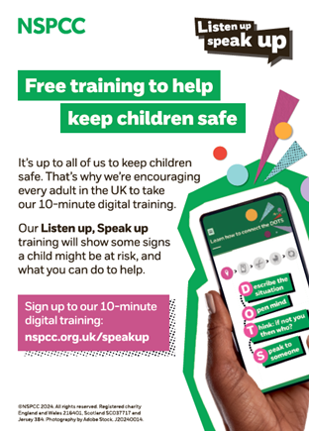
Year 6 SATs revision club
As the year 6 SATs approach, we are offering year 6s a before school, lunch time or after school club to get ready for their SATs
This club will start from Tuesday 16th April.

Please follow the link to sign your child up:
https://forms.office.com/e/Q72GeLkF3b
Important up and coming dates
Yr 8 Liverpool trip 30th April 2024 (deposit should already be in. Full payment information
Yr 8 Leavers hoodies deadline 10th May through super sport
Yr 7&8 Alton towers trip 18th July 2024
Y6 Bowling Tuesday 16th July

Garden donations
With spring here and the plants and trees starting to bloom, we are making a start on creating our SEN garden.
We would highly appreciate any donations of plants, seeds, herbs, bulbs and garden decorations.
Thank you in advance.

Financial Support
The MBTF is the legacy of Robert Schofield Milner, a Leek businessman who was passionate about improving the lives of young people who go to school in Leek, through education. The trust fund helps to support low income families with educational activities. Families can apply for grants to help pay for school trips - such a camp, overseas trips, subject or theatre trips. Grants can be for a contribution towards the activity or the full amount depending on the family financial situation.
Application forms are available from the school. Information supplied on these forms is subject to current GDPR legislation.

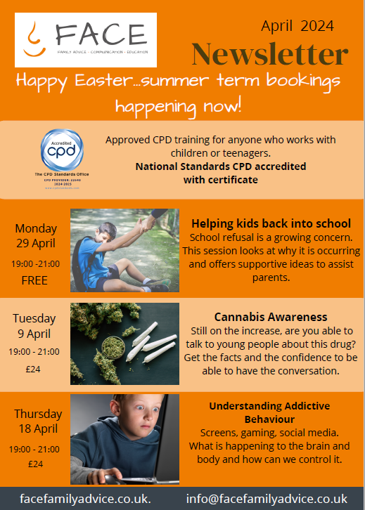

New Football kits
The PE department would like to say a big thank you to LC Construction LTD who have kindly sponsored our year 7 and 8 football kits. We think they look brilliant!
Here is the two captains and some of our goalkeepers wearing them.
Not only did pupils came up with the designs, we think they look very professional and we look forward to wearing them in our upcoming fixtures.
A big thank you to Fused sport for producing the kits and supporting us with this process.



Your School Lottery: Win a £1,000 Sainsbury’s eGift card!
Support a good cause on the lottery this month, and you could win an amazing £1,000 Sainsbury’s voucher in March’s Super Draw! Stock up your wardrobe for Spring with Tu, freshen up your home with Habitat homewares, or just save some money on your groceries – what a way to kick-start Spring! Get your tickets before Saturday 30th March to be in with your chance to win. Already have tickets? Don’t forget, you can top-up your tickets just for Super Draw week!
Want to win an extra £200? Score an extra chance to win a bonus £200 Amazon gift card this month and help out a good cause by referring a friend.
To enter and receive your tickets and to also refer a friend, please follow the link: https://www.yourschoollottery.co.uk/lottery/school/churnet-view-middle-school

MyEd

Keep up to date with your child, all information regarding trips, snow and any other important information. If not you will not receive any reminders. Just go to your app store, search for MyEd and download the app. The app is free to use.

https://www.myedschoolapp.com/



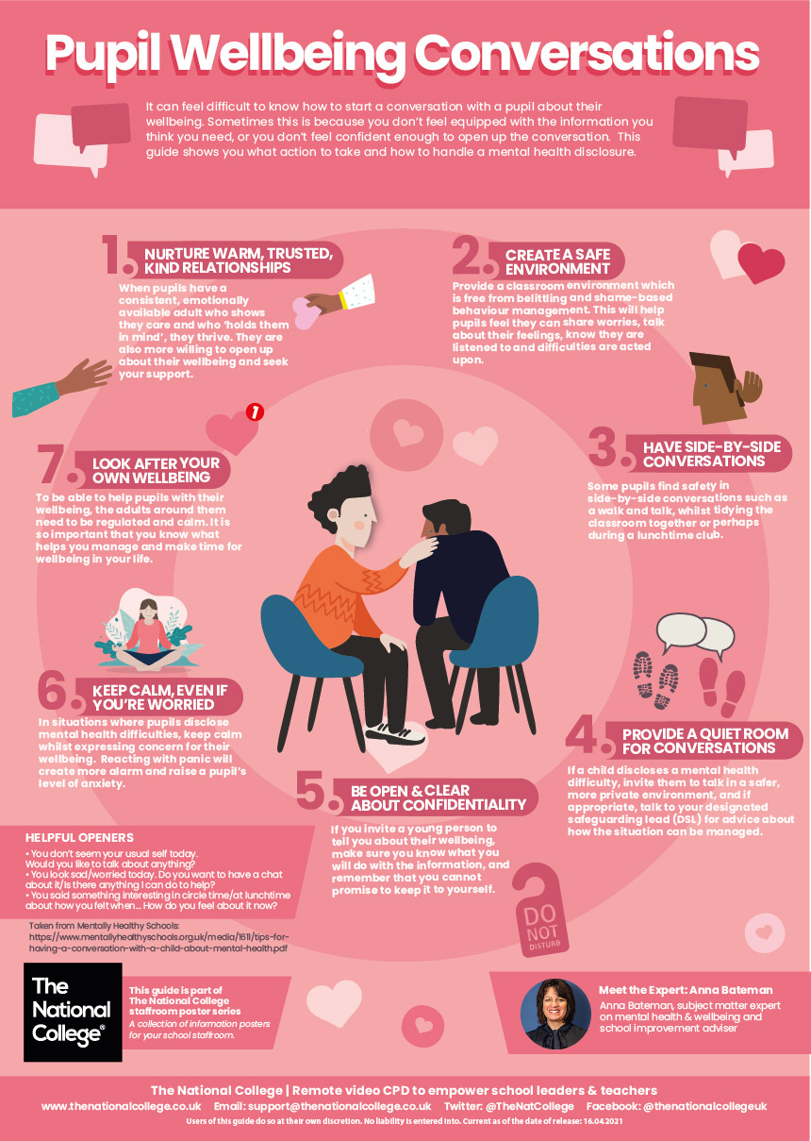
Core values

Below are the pupils who were awarded the most Core Value points the week beginning the 4th March 2024. Well done to everybody for their achievements!
Year 7
Gibbons:
Loeisha Venables
Hargrave:
Alannah Hudson
George Harvey
Horowitz:
Imogen Arfield
Lenny Hibbitts
Riodan:
Hannah Bethell
Joseph Shallcross
Sachar:
Leah Thompson
Jayden Lovatt
Year 5
Dahl:
Mary Bullivant-Ball
Jack Stennings
Hughs:
Lily Byatt
William Sexon
Mackenzie:
Isabelle Blaymires
Travis Richardson
Morpurgo:
Sophie Stretton
Oliver Lea
Palacio:
Fliss Cope
Alex King

Year 6
Carroll
Holly Fearns
Huw Davies
Fletcher:
Lexi Richards
Noah Whiston
Noyes
Chloe Hall
Alfie Buxton
Pullman
Iona Harrison
George Moss
Rowling:
Natasha Dando
Thompson
Chloe Higginbotham
Leo Evans
Year 8
Blackman:
Libby-Mai Pickford
Ashton Hambleton
Fountain:
Elodie Wells
Joe Miller
Hill:
Daisy Wardman
Dominic Fernandes
Stevens
Stevie Swindells
Ashton Walters
Stoker:
Eliza Crooks
Oliver Stretton
Zephanier:
Maisie Morris
Joseph Mellor

